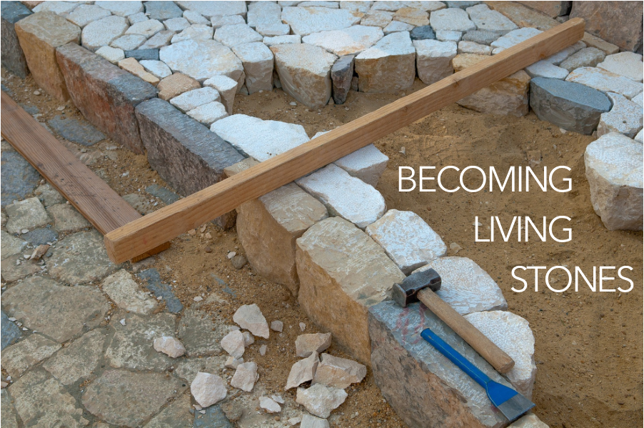

Welcome to the living Stone, the source of life. The [workers] took one look and threw it out; God set it in the place of honor. Present yourselves as building stones for the construction of a sanctuary vibrant with life, in which you’ll serve as holy priests offering Christ-approved lives up to God. The Scriptures provide precedent:

Look! I’m setting a stone in Zion,

a cornerstone in the place of honor.

Whoever trusts in this stone as a foundation

will never have cause to regret it.

1 Peter 2:4-6, The Message

Over the last six weeks, we have moved from confronting our fear, the things that cause us to trip in our walk with Jesus, and our longing to stay safely away from the world, to a recognition that God is not contained inside walls, but instead God’s house is much larger than just us. We are called to be the church in the world and to be living stones built into a spiritual house.

WELCOME

Welcome to the living Stone, the source of life. The workers took one look and threw it out; God set it in the place of honor.

**We present ourselves as building stones for the construction of a sanctuary vibrant with life, in which we will serve as holy priests offering Christ-approved lives up to God.**

PRELUDE

CALL TO WORSHIP

Come to him, a living stone, though rejected by mortals yet chosen and precious in God’s sight.

**Let us, like living stones, be built into a spiritual temple; a holy priesthood.**

We came with doubts…

**but the millstone has been lifted.**

We stumbled unseeing on our journey with Christ,

**but now our footsteps are sure.**

Like thieves we scaled a rock wall,

**Seeking to find security.**

God’s house has many rooms.

**We are ready to encounter God in unlikely places.**

God is not limited to one place or one time.

**We will serve beyond the church walls to where God calls us.**

You are called to be living stones, in this congregation and out in the world.

**We are living stones, we are a spiritual house, we are a holy priesthood!**

**CHRIST IS MADE THE SURE FOUNDATION** / Glory to God 394

Our service of worship begins as we GATHER.

We sing our praises to God,

we are called to worship God,

we confess to God together,

we are reminded of God’s pardon of what we confess, and

we share signs of peace as we greet one another.

When we sing, we sing together, heeding Psalm 84, which encourages us all to:

Make a joyful noise to the Lord, all the earth;

break forth into joyous song and sing praises.

Our worship of God involves us all so there are many times when we speak together or when we respond to the leading of another. These times when we speak (and sing) together are noted by **bold text**.

CALL TO CONFESSION

We confess together as a community of faith because we acknowledge the reality of sin in the church, the world, and our personal lives, and so we ask God for forgiveness and help in amending our lives. And the proof of God’s amazing love is this: while we were sinners Christ died for us. Because we have faith in him, we dare to approach God with confidence, assured of a forgiveness already given through Christ. So, in faith and penitence, let us confess our sin before God and one another, first together and then in silence.

**PRAYER OF CONFESSION** FotW

**God, though you call us to delight in your teachings, we can become cynical and full of doubt. Do not judge us, we pray, but heal us and restore us to you. Guard us and protect us from evil, and sanctify us in truth; in Jesus’ name. Amen.**

ASSURANCE OF FORGIVENESS

Friends, hear the good news! Who is in a position to condemn? Only Christ, and Christ died for us, Christ rose for us, Christ reigns in power for us, Christ prays for us. Anyone who is in Christ is a new creation. The old life has gone; a new life has begun. Know that we are forgiven and be at peace. **Amen.**

CHILDREN’S MESSAGE

*Supplies: many small stones*

I’m going to try to make a good, strong church building with these rocks. I want to make it tall, but also make it sturdy so that it can’t fall over.

*After several attempts that (presumably) fall over, leader explains:*

What we are missing is the cornerstone. The cornerstone is the most important stone of all because it helps the builder make sure that all the other rocks are laid out nice and straight. It starts the whole building. The other stones can be put in place because the cornerstone is in the exact right spot and is the exact right shape and size.

In the Bible, Jesus was called the cornerstone of the church. That’s confusing because Jesus was not actually a rock. The Bible also calls Jesus a Living Stone. He wasn’t like these rocks; he was alive.

But, like a cornerstone in a building, Jesus is the most important part of the church, not just a building we can sit in, but the all the people of the church. Jesus helps us to make sure that everything we do is nice and straight. If we base everything we do - the music, our prayers, our work outside the church - on Jesus, then we have a strong foundation for the church.

Let’s pray: Jesus, we thank you for being the most important part of our church. When we listen to the stories of you in the Bible and when we pray to you, you teach us how to do what is right and true. Thank you for being a Living Stone and the cornerstone of the church. Amen!

We continue our worship as the Word is PROCLAIMED.

We pray that the Holy Spirit helps us receive the Word spoken,

we hear Scripture(s) in song and word,

we listen to a reflection on the Scripture(s), and

we begin our own reflection during a period of quiet.

We RESPOND to the Word as:

We affirm our faith in song,

we offer our prayers to God, and

we commit through offering to God’s work in the world.

On the first Sunday of each month, we celebrate the Lord’s Supper.

Through the seasons of the church, we also baptize children of God, ordain and install officers, and respond to God’s call upon us through other expressions.

PRAYER FOR ILLUMINATION FotW

May the reading of your Word sanctify us in the truth and bring us to perfect joy. **Amen.**

SCRIPTURE / 1 Peter 2:4-6

MESSAGE

**CALLED AS PARTNER’S IN CHRIST’S SERVICE** / Glory to God 761

PRAYERS OF THE PEOPLE

God, our foundation, you hear the cries of the world and you send each of us out for one another, both steady as a rock and soft with your love. Keep before us the life and way of Jesus, who showed us the way of being in the world, unyielding in demanding justice for all, and gentle with grace and kindness for all who suffered.

When we waver, give us courage.

When we doubt, give us strength.

When we refuse, realign us.

When we forget, remind us.

When we ourselves cry out, send your tenderness in another.

When we hear the cries of others, turn us toward them.

When we want to hide, draw us out.

When we go out as living stones, nourish us for the next time.

We ask all of these things through Christ, who taught us to pray, saying:

LORD’S PRAYER

As the service of worship of God comes to a close, we acknowledge that God SENDS us out into the world to be bearers of the good news of God.

We sing a song affirming the calls God has placed on our hearts,

we receive a charge reminding us of God’s call, and

we are bid into the work of God with a blessing.

OFFERING

The cornerstone on which the church is built is Jesus Christ, who offers the true measuring line for all we build in his name. Like him, you are called to be living stones, true and stable, in this congregation and in the community. Your faithful gifts are one way that we can continue to build on the foundation of Jesus Christ. Please consider giving online or by check this week.

ANNOUNCEMENTS

**LORD, YOU GIVE THE GREAT COMMISSION** / Glory to God 298

CHARGE & BENEDICTION

Over these last six weeks, we have borne the weight of doubt like a millstone and have stumbled along the rocky road to Emmaus. We have built walls to protect us and insulate us, only to learn that God is building a church that does not have walls of rock and mortar, but a church on which Jesus Christ, a living stone, is the foundation.

Now then, you must be living stones as well, the church visible in the world through your demonstration of compassion, justice, and praise. In this renewed calling, remember that you are precious in God’s sight.

Let yourselves be the living stones out in the world. You are invited to take the stone you’ve been holding as part of your worship these weeks and place it prominently as a reminder of your call from God.

POSTLUDE

FotW: Feasting on the Word: Liturgies for Year B, Volume 1 - Worship Companion; Seventh Sunday of Easter