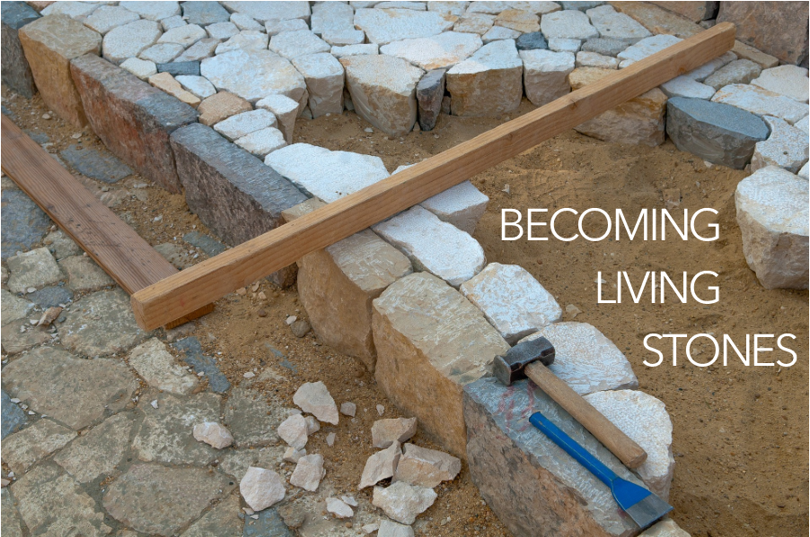

**CALLED AS PARTNER’S IN CHRIST’S SERVICE** / Glory to God 761

PRAYERS OF THE PEOPLE

LORD’S PRAYER

OFFERING

ANNOUNCEMENTS

We RESPOND to the Word as:

we affirm our faith in song,

we offer our prayers to God, and

we commit through offering to God’s work in the world.

On the first Sunday of each month, we celebrate the Lord’s Supper.

Through the seasons of the church, we also baptize children of God, ordain and install officers, and respond to God’s call upon us through other expressions.

As the service of worship of God comes to a close, we acknowledge that God SENDS us out into the world to be bearers of the good news of God.

We sing a song affirming the calls God has placed on our hearts,

we receive a charge reminding us of God’s call, and

we are bid into the work of God with a blessing.

**LORD, YOU GIVE THE GREAT COMMISSION** / Glory to God 298

CHARGE & BENEDICTION

POSTLUDE

FotW: Feasting on the Word: Liturgies for Year B, Volume 1 - Worship Companion; Seventh Sunday of Easter

Welcome to the living Stone, the source of life. The [workers] took one look and threw it out; God set it in the place of honor. Present yourselves as building stones for the construction of a sanctuary vibrant with life, in which you’ll serve as holy priests offering Christ-approved lives up to God. The Scriptures provide precedent:

Look! I’m setting a stone in Zion,

a cornerstone in the place of honor.

Whoever trusts in this stone as a foundation

will never have cause to regret it.

1 Peter 2:4-6, The Message

You are invited to find a stone you can hold, to be included as part of your worship.

WELCOME

Welcome to the living Stone, the source of life. The workers took one look and threw it out; God set it in the place of honor.

**We present ourselves as building stones for the construction of a sanctuary vibrant with life, in which we will serve as holy priests offering Christ-approved lives up to God.**

PRELUDE

CALL TO WORSHIP

Come to him, a living stone, though rejected by mortals yet chosen and precious in God’s sight.

**Let us, like living stones, be built into a spiritual temple; a holy priesthood.**

We came with doubts…

**but the millstone has been lifted.**

We stumbled unseeing on our journey with Christ,

**but now our footsteps are sure.**

Like thieves we scaled a rock wall,

**Seeking to find security.**

God’s house has many rooms.

**We are ready to encounter God in unlikely places.**

God is not limited to one place or one time.

**We will serve beyond the church walls to where God calls us.**

You are called to be living stones, in this congregation and out in the world.

**We are living stones, we are a spiritual house, we are a holy priesthood!**

**CHRIST IS MADE THE SURE FOUNDATION** / Glory to God 394

CALL TO CONFESSION

**PRAYER OF CONFESSION** FotW

**God, though you call us to delight in your teachings, we can become cynical and full of doubt. Do not judge us, we pray, but heal us and restore us to you. Guard us and protect us from evil, and sanctify us in truth; in Jesus’ name. Amen.**

ASSURANCE OF FORGIVENESS

Friends, hear the good news! Who is in a position to condemn? Only Christ, and Christ died for us, Christ rose for us, Christ reigns in power for us, Christ prays for us. Anyone who is in Christ is a new creation. The old life has gone; a new life has begun. Know that we are forgiven and be at peace. **Amen.**

Our service of worship begins as we GATHER.

We sing our praises to God,

we are called to worship God,

we confess to God together,

we are reminded of God’s pardon of what we confess, and

we share signs of peace as we greet one another.

When we sing, we sing together, heeding Psalm 84, which encourages us all to:

Make a joyful noise to the Lord, all the earth;

break forth into joyous song and sing praises.

Our worship of God involves us all so there are many times when we speak together or when we respond to the leading of another. These times when we speak (and sing) together are noted by **bold text**.

If you are comfortable, you are invited to stand whenever you see the standing icon.

We continue our worship as the Word is PROCLAIMED.

We pray that the Holy Spirit helps us receive the Word spoken,

we hear Scripture(s) in song and word,

we listen to a reflection on the Scripture(s), and

we begin our own reflection during a period of quiet.

CHILDREN’S MESSAGE

PRAYER FOR ILLUMINATION FotW

May the reading of your Word sanctify us in the truth and bring us to perfect joy. **Amen.**

SCRIPTURE / 1 Peter 2:4-6

MESSAGE