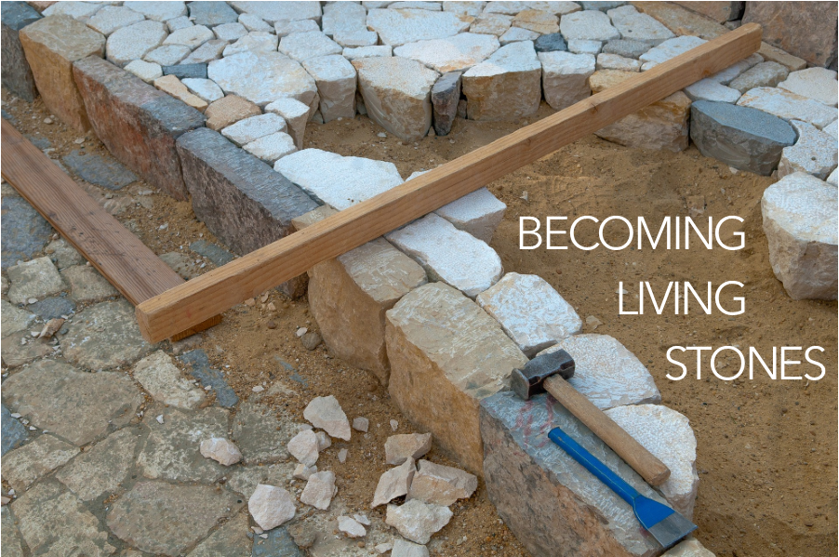

**GOD OF OUR LIFE** / Glory to God 686

PRAYERS OF THE PEOPLE

LORD’S PRAYER

OFFERING

ANNOUNCEMENTS

We RESPOND to the Word as:

We affirm our faith in song,

we offer our prayers to God, and

we commit through offering to God’s work in the world.

On the first Sunday of each month, we celebrate the Lord’s Supper.

Through the seasons of the church, we also baptize children of God, ordain and install officers, and respond to God’s call upon us through other expressions.

As the service of worship of God comes to a close, we acknowledge that God SENDS us out into the world to be bearers of the good news of God.

We sing a song affirming the calls God has placed on our hearts,

we receive a charge reminding us of God’s call, and

we are bid into the work of God with a blessing.

**THE CHURCH OF CHRIST CANNOT BE BOUND** / Glory to God 766

CHARGE & BENEDICTION

POSTLUDE

Finding God: posted on the Presbyterian Church USA website; https://www.pcusa.org/site_media/media/uploads/peacemaking/pdf/mlk-resources.pdf

FotW: Feasting on the Word: Liturgies for Year B, Volume 1 Worship Companion; Sixth Sunday of Easter

You are coming to Christ, who is the living cornerstone of God’s temple. He was rejected by people, but he was chosen by God for great honor.

And you are living stones that God is building into his spiritual temple. What’s more, you are his holy priests. Through the mediation of Jesus Christ, you offer spiritual sacrifices that please God. As the Scriptures say,

“I am placing a cornerstone in Jerusalem,

chosen for great honor,

and anyone who trusts in him

will never be disgraced.”

1 Peter 2:4-6, NLT

CHILDREN’S MESSAGE

PRAYER FOR ILLUMINATION FotW

Pour out your Holy Spirit upon us, O God, in the reading of your Word, that we would hear what you have to say to us today. May your Holy Spirit be poured out upon us; through Jesus Christ. **Amen.**

SCRIPTURE / Acts 17:22-31

MESSAGE

We continue our worship as the Word is PROCLAIMED.

We pray that the Holy Spirit helps us receive the Word spoken,

we hear Scripture(s) in song and word,

we listen to a reflection on the Scripture(s), and

we begin our own reflection during a period of quiet.

Our service of worship begins as we GATHER.

We sing our praises to God,

we are called to worship God,

we confess to God together,

we are reminded of God’s pardon of what we confess, and

we share signs of peace as we greet one another.

When we sing, we sing together, heeding Psalm 84, which encourages us all to:

Make a joyful noise to the Lord, all the earth;

break forth into joyous song and sing praises.

Our worship of God involves us all so there are many times when we speak together or when we respond to the leading of another. These times when we speak (and sing) together are noted by **bold text**.

**the rhythm of a heartbeat.**

**We worship the God who inhabits our world**

**and who indwells our lives.**

**GOD, YOU SPIN THE WHIRLING PLANETS** / Glory to God 23

CALL TO CONFESSION

**PRAYER OF CONFESSION** FotW

**Loving God, we have not loved you or each other with our whole hearts. Forgive us, we pray, and lead us toward wholeness, that we may be filled with your joy. In Jesus’ name we pray. Amen.**

ASSURANCE OF FORGIVENESS

Friends, hear the good news! Who is in a position to condemn? Only Christ, and Christ died for us, Christ rose for us, Christ reigns in power for us, Christ prays for us. Anyone who is in Christ is a new creation. The old life has gone; a new life has begun. Know that we are forgiven and be at peace. **Amen.**

WELCOME & INVITATION

You are coming to Christ, who is the living cornerstone of God’s temple. He was rejected by people, but he was chosen by God for great honor.

**And we are living stones that God is building into a spiritual temple. What’s more, we are God’s holy priests. Through the mediation of Jesus Christ, we offer spiritual sacrifices that please God.**

PRELUDE

CALL TO WORSHIP / Finding God

**We worship the God who inhabits our world**

**and indwells our lives.**

**We need not look up to find God,**

**we need only to look around:**

**within ourselves,**

**beyond ourselves,**

**into the eyes of another.**

**We need not listen for a distant thunder to find God,**

**we need only listen to the music of life,**

**the words of children,**

**the questions of the curious,**