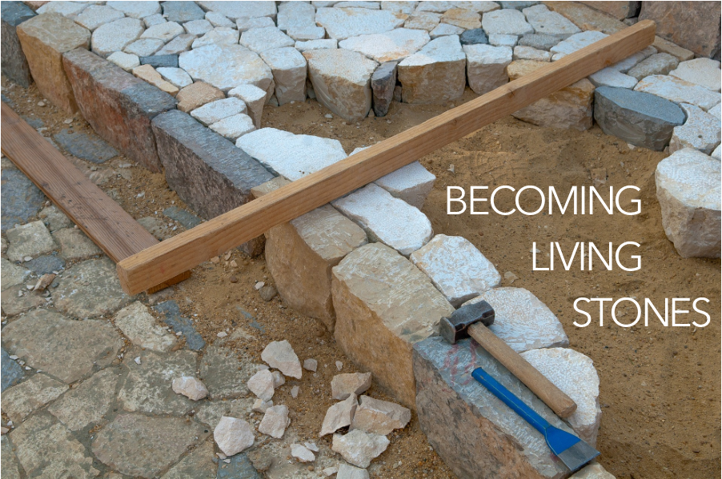

Now you are coming to him as to a living stone. Even though this stone was rejected by humans, from God’s perspective it is chosen, valuable. You yourselves are being built like living stones into a spiritual temple. You are being made into a holy priesthood to offer up spiritual sacrifices that are acceptable to God through Jesus Christ. Thus it is written in scripture, Look! I am laying a cornerstone in Zion, chosen, valuable. The person who believes in him will never be shamed.

1 Peter 2:4-6, CEB

You are invited to find a stone you can hold, to be included as part of your worship. You will be invited to lay down your stone during the second hymn.

WELCOME & INVITATION

Now you are coming to him as to a living stone. Even though this stone was rejected by humans, from God’s perspective it is chosen, valuable.

**We ourselves are being built like living stones into a spiritual temple. We are being made into a holy priesthood to offer up spiritual sacrifices that are acceptable to God through Jesus Christ.**

PRELUDE

CALL TO WORSHIP

Jesus said, I go and prepare a place for you, and I will come again.

**We gather in this place to know your presence and your love.**

Jesus said, I am the Way, and the Truth, and the Life. If you know me, you know God.

**We pray to know you more deeply, that we may know God more intimately.**

Jesus said, in God’s house there are many rooms, there are many places where God dwells on earth.

**We search to know God out in the world, to engage more deeply and love more thoroughly.**

Let us begin by, together, worshipping God in this place and at this time.

**SING PRAISE TO GOD WHO REIGNS ABOVE** / Glory to God 645

CALL TO CONFESSION

**PRAYER OF CONFESSION** FotW

**God of mercy, we confess that we have not borne the fruit of the Spirit. We have not loved others as you have loved us. We have denied the promises of baptism and cut ourselves off from you. Forgive us, restore us, that we may abide in your love and live out your mercy, for the sake of Jesus Christ, in whose name we pray. Amen.**

ASSURANCE OF FORGIVENESS

Friends, hear the good news! Who is in a position to condemn? Only Christ, and Christ died for us, Christ rose for us, Christ reigns in power for us, Christ prays for us. Anyone who is in Christ is a new creation. The old life has gone; a new life has begun. Know that we are forgiven and be at peace. **Amen.**

Our service of worship begins as we GATHER.

We sing our praises to God,

we are called to worship God,

we confess to God together,

we are reminded of God’s pardon of what we confess, and

we share signs of peace as we greet one another.

When we sing, we sing together, heeding Psalm 84, which encourages us all to:

Make a joyful noise to the Lord, all the earth;

break forth into joyous song and sing praises.

Our worship of God involves us all so there are many times when we speak together or when we respond to the leading of another. These times when we speak (and sing) together are noted by **bold text**.

We continue our worship as the Word is PROCLAIMED.

We pray that the Holy Spirit helps us receive the Word spoken,

we hear Scripture(s) in song and word,

we listen to a reflection on the Scripture(s), and

we begin our own reflection during a period of quiet.

CHILDREN’S MESSAGE

PRAYER FOR ILLUMINATION FotW

SCRIPTURE / John 14:1-4

MESSAGE

**FROM ALL THAT DWELL BELOW THE SKIES** / Glory to God 327

PRAYERS OF THE PEOPLE

LORD’S PRAYER

OFFERING

ANNOUNCEMENTS

We RESPOND to the Word as:

We affirm our faith in song,

we offer our prayers to God, and

we commit through offering to God’s work in the world.

On the first Sunday of each month, we celebrate the Lord’s Supper.

Through the seasons of the church, we also baptize children of God, ordain and install officers, and respond to God’s call upon us through other expressions.

As the service of worship of God comes to a close, we acknowledge that God SENDS us out into the world to be bearers of the good news of God.

We sing a song affirming the calls God has placed on our hearts,

we receive a charge reminding us of God’s call, and

we are bid into the work of God with a blessing.

**O CHRIST, THE GREAT FOUNDATION** / Glory to God 361

CHARGE & BENEDICTION

POSTLUDE

FotW: Feasting on the Word: Liturgies for Year B, Volume 1 - Worship Companion; Fifth Sunday of Easter