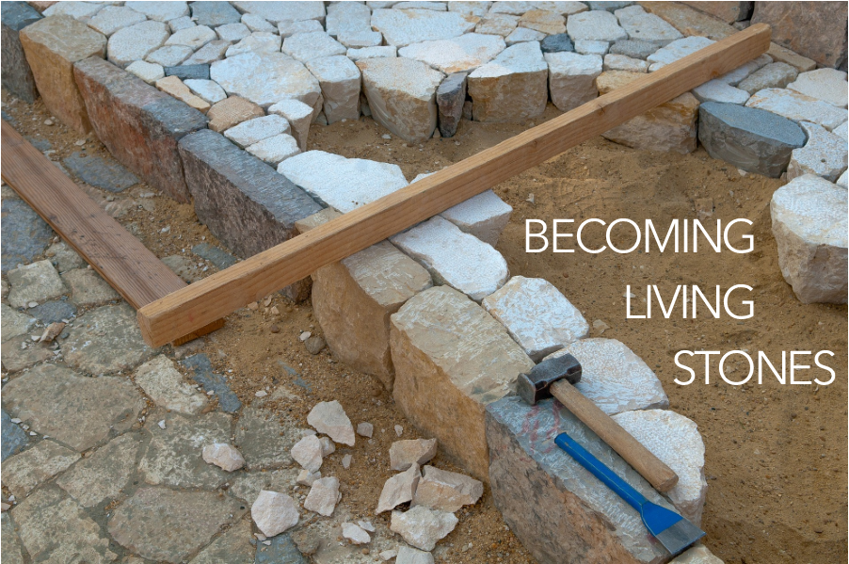

Come to him, a living stone, though rejected by mortals yet chosen and precious in God’s sight, and like living stones, let yourselves be built into a spiritual house, to be a holy priesthood, to offer spiritual sacrifices acceptable to God through Jesus Christ. For it stands in scripture:

“See, I am laying in Zion a stone,

a cornerstone chosen and precious;

and whoever believes in him will not be put to shame.”

1 Peter 2:4-6, NRSV

You are invited to find a stone you can hold, to be included as part of your worship. You will be invited to lay down your stone as a part of our Prayer of Confession.

WELCOME & INVITATION

Come to him, a living stone, though rejected by mortals yet chosen and precious in God’s sight.

**Like living stones, let us be built into a spiritual house; a holy priesthood.**

PRELUDE

CALL TO WORSHIP

Let us rejoice! The risen Christ is among us and greets us with the message of Peace!

**Like the disciples, we rejoice at the good news! Like the disciples, we also have our doubts.**

Jesus said, “Blessed are those who have not seen and yet have come to believe.”

**Open our hearts, O God, so that we too may have faith and not feel weighed down by our doubt!**

The risen Christ invites us to receive the Holy Spirit and to share the Good News.

**Let us be filled with the spirit and embrace the peace of Christ.**

**THINE IS THE GLORY** / Glory to God 238

CALL TO CONFESSION

PRAYER OF CONFESSIONFotW

**You have shown yourself to us, O God, by Word and Spirit, with signs and wonders, in flesh and blood, yet we still struggle to live and believe the good news of Jesus Christ. Have mercy on us; forgive us. Enter into our lives and cast out our fear so that we may come to trust in you and have life in Jesus’ name. Amen.**

ASSURANCE OF FORGIVENESS

Friends, hear the good news! Who is in a position to condemn? Only Christ, and Christ died for us, Christ rose for us, Christ reigns in power for us, Christ prays for us. Anyone who is in Christ is a new creation. The old life has gone; a new life has begun. Know that we are forgiven and be at peace. **Amen.**

Our service of worship begins as we GATHER.

We sing our praises to God,

we are called to worship God,

we confess to God together,

we are reminded of God’s pardon of what we confess, and

we share signs of peace as we greet one another.

When we sing, we sing together, heeding Psalm 84, which encourages us all to:

Make a joyful noise to the Lord, all the earth;

break forth into joyous song and sing praises.

Our worship of God involves us all so there are many times when we speak together or when we respond to the leading of another. These times when we speak (and sing) together are noted by **bold text**.

CHILDREN’S MESSAGE

PRAYER FOR ILLUMINATIONFotW

SCRIPTURE / John 20:19-31

MESSAGE

**WE WALK BY FAITH AND NOT BY SIGHT** / Glory to God 817

CHARGE & BENEDICTION

POSTLUDE

FotW: Feasting on the Word: Liturgies for Year B, Volume 1 - Worship Companion; Second Sunday of Easter

We continue our worship as the Word is PROCLAIMED.

We pray that the Holy Spirit helps us receive the Word spoken,

we hear Scripture(s) in song and word,

we listen to a reflection on the Scripture(s), and

we begin our own reflection during a period of quiet.

We RESPOND to the Word as:

We affirm our faith in song,

we offer our prayers to God, and

we commit through offering to God’s work in the world.

On the first Sunday of each month, we celebrate the Lord’s Supper.

Through the seasons of the church, we also baptize children of God, ordain and install officers, and respond to God’s call upon us through other expressions.

As the service of worship of God comes to a close, we acknowledge that God SENDS us out into the world to be bearers of the good news of God.

We sing a song affirming the calls God has placed on our hearts,

we receive a charge reminding us of God’s call, and

we are bid into the work of God with a blessing.

**THAT EASTER DAY WITH JOY WAS BRIGHT** / Glory to God 254

PRAYERS OF THE PEOPLE

LORD’S PRAYER

OFFERING

ANNOUNCEMENTS