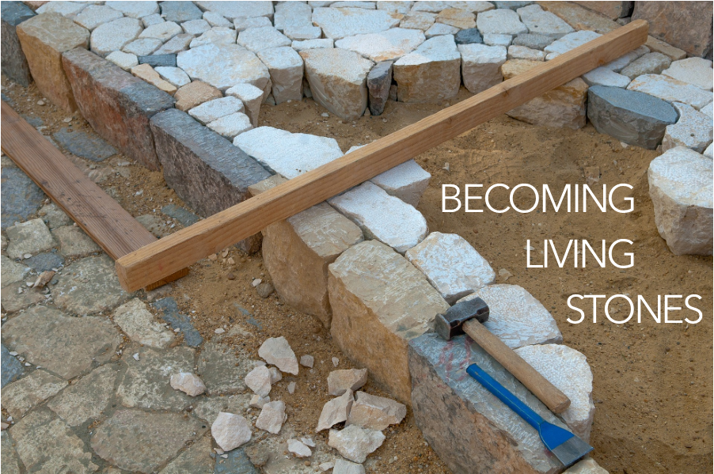

As you come to him, a living stone rejected by [humans] but in the sight of God chosen and precious, you yourselves like living stones are being built up as a spiritual house, to be a holy priesthood, to offer spiritual sacrifices acceptable to God through Jesus Christ. For it stands in Scripture:

“Behold, I am laying in Zion a stone,

a cornerstone chosen and precious,

and whoever believes in him will not be put to shame.”

1 Peter 2:4-6, ESV

We are in the midst of a worship series that links us to the early church in the time following Jesus’ resurrection. We’ve felt the weight of fear and recognized what causes us to stumble in our faith. Today, we find ourselves behind closed walls, like sheep seeking security. How will we respond to the voice of our Shepherd? In the following four weeks of worship, you are invited to find a stone you can hold, to be included as part of your worship.

WELCOME & INVITATION

As you come to him, a living stone rejected by humans but in the sight of God chosen and precious…

**We, like living stones, are being built up as a spiritual house, to be a holy priesthood, to offer spiritual sacrifices acceptable to God.**

Our lives are often times fast paced and we are called in many different directions that compete for our time, attention, and resources. Too often the noises of our “modern” world inhibit our ability to hear the call from the Good Shepherd, to hear the call of Jesus and how he leads us to be engaged in the world. We choose to remain behind our known walls. While holding your stone think about what drowns out or distracts you from hearing the call to follow.

You will be invited to lay down your stone as a response to today’s sermon/message.

PRELUDE

CALL TO WORSHIP

We gather together in the presence of our Shepherd God.

**The One who calls us each by name, who restores our souls, and leads us in the way of righteousness.**

God’s goodness and love never stop pursuing us.

**This is the God we have come to worship!**

**THE KING OF LOVE MY SHEPHERD IS** / Glory to God 802

CALL TO CONFESSION

We confess together as a community of faith because we acknowledge the reality of sin in the church, the world, and our personal lives, and so we ask God for forgiveness and help in amending our lives. And the

Our service of worship begins as we GATHER.

We sing our praises to God,

we are called to worship God,

we confess to God together,

we are reminded of God’s pardon of what we confess, and

we share signs of peace as we greet one another.

When we sing, we sing together, heeding Psalm 84, which encourages us all to:

Make a joyful noise to the Lord, all the earth;

break forth into joyous song and sing praises.

Our worship of God involves us all so there are many times when we speak together or when we respond to the leading of another. These times when we speak (and sing) together are noted by **bold text**.

proof of God’s amazing love is this: while we were sinners Christ died for us. Because we have faith in him, we dare to approach God with confidence, assured of a forgiveness already given through Christ. So, in faith and penitence, let us confess our sin before God and one another, first together and then in silence.

PRAYER OF CONFESSION FotW

**Lord, have mercy on us. We talk about love, but our actions betray us. We talk about love, but we neglect the poor. We talk about love, but we fail to love one another. Lord, have mercy on us. Forgive us, and abide in us by the power of your Spirit so that our lives may show our love for Jesus Christ, in whose body we live and in whose name we pray. Amen.**

ASSURANCE OF FORGIVENESS

Friends, hear the good news! Who is in a position to condemn? Only Christ, and Christ died for us, Christ rose for us, Christ reigns in power for us, Christ prays for us. Anyone who is in Christ is a new creation. The old life has gone; a new life has begun. Know that we are forgiven and be at peace. **Amen.**

CHILDREN’S MESSAGE

*Supplies: rocks and cotton balls*

*Leader builds a circle of stones and places cotton balls inside to represent sheep behind their walled close.*

When Jesus lived, one of the jobs that people had was to take care of sheep. Do you take care of any animals? How do you keep them safe? For sheep, the shepherds would move the sheep behind walls, so that wild animals couldn’t get in to attack them. At nighttime, the sheep could all be together safe behind their walls.

In the morning, the person who took care of the sheep - called a shepherd - would open up a little space in the wall - a gate - and call the sheep out. The shepherd would lead the sheep to pastures or fields of green grass, so they could eat. *Leader can demonstrate this w/the cotton balls.*

What would happen if the sheep wouldn’t come out? In the morning if the sheep heard the shepherd’s voice, but wouldn’t come out, what do you think would happen? Maybe the sheep were too scared to come out. Where is their food? How can they get their food, if they stay behind the walls? What should the sheep do when the shepherd calls to them?

Let’s pray: Jesus, we thank you for taking care of us and keeping us safe. When you call us outside of the church and to be with all sorts of people, help us not be afraid, but to listen to you. We know that you love us. We trust you to lead us to good places. Amen!

PRAYER FOR ILLUMINATION FotW

Lord God, Good Shepherd, by the leading of your Spirit, help us to listen for your voice and follow in your paths all the days of our lives; in Jesus’ name. **Amen.**

We continue our worship as the Word is PROCLAIMED.

We pray that the Holy Spirit helps us receive the Word spoken,

we hear Scripture(s) in song and word,

we listen to a reflection on the Scripture(s), and

we begin our own reflection during a period of quiet.

We RESPOND to the Word as:

We affirm our faith in song,

we offer our prayers to God, and

we commit through offering to God’s work in the world.

On the first Sunday of each month, we celebrate the Lord’s Supper.

Through the seasons of the church, we also baptize children of God, ordain and install officers, and respond to God’s call upon us through other expressions.

SCRIPTURE / John 10:1-10

MESSAGE

During the hymn find a place and lay down your stone, your distractions, into God’s keeping now.

**GOD IS CALLING THROUGH THE WHISPER** / Glory to God 410

PRAYERS OF THE PEOPLE

God who exists without bounds or limits, you call us to confidently live the same way, but fears and worries about scarcity and discomfort slow us, even stop us. In this Easter season especially, help us remember the ways our risen Christ lived fully - trusting in you, undaunted by the unknown. Grant us a measure of courage each day, that we might live and love more expansively than we did the day before.

God, when challenges are in front of us, too often we doubt our ability to lean into them or find the emotions bigger than we think we can bear. We forget that we are not solitary beings, but are surrounded by clouds of witnesses who have trod similar paths, seen similar difficulties, carried similar burdens. Most of all we forget that you go with us, calling us into what is next, beckoning as one who goes before us, behind us, and alongside us. Help us to remember your presence which never leaves us alone.

God, we pray your tangible, clear presence with all who know fear, with all who seek health, with all who will die, with all who feel lost, with those whose tears have run dry and those whose tears will not stop. Send your Spirit of comfort upon all those facing days and nights which feel difficult and heavy and long, we pray, that they might experience peace. Amen.

OFFERING

We build walls around us to create the sense of safety: personal safety, emotional protection, financial security. The Good Shepherd, however, only allows us to stay behind those walls for a short time; he calls us out, one by one, knowing we can only experience abundant life once we go beyond the walls and into the green pastures. In gratitude for that promise of abundance, please consider giving online or by check this week.

**[ADAPT OR REMOVE AS DESIRED]**

COMMUNION

INVITATION

We have set this table with tangible signs of the stumbling blocks on our Christian journey - the stones that weigh us down and cause us to trip - the stones that we use for a false sense of protection and security.

Those are the burdens we bring to this table.

We are invited to lay those stones here and feel the weight of that burden lifting. During this Easter Season, we are reminded of the One who resisted the temptation to turn stones into bread, choosing instead to become for us the Bread of Life. We are reminded of the One who could not be kept dead in the tomb, but instead rolled away the heavy stone to rejoin God in heaven. We give thanks in this Easter Season for the One who has become a Living Stone, inviting us - all of us who are willing to accept him and seek the forgiveness of sins - to share in this meal and to receive the promise of new life.

Let us offer our thanksgiving to God for this gift:

GREAT THANKSGIVING

The Lord be with you!

**And also with you.**

Lift up your hearts.

**We lift them up to the Lord.**

Let us give thanks to the Lord our God.

**It is right to give our thanks and praise.**

It is indeed right, O God, to give you our thanks and praise. You have given a gift to us that is scarcely imaginable: the gift of Jesus Christ, no longer crucified and dead, but resurrected. In this gift, you cover us with grace and, like the shepherd, call us out from behind our walls into abundant life. Therefore, we join our voices with all creation and all ages to proclaim the glory of your name:

**Holy, holy, holy Lord, God of power and might, heaven and earth are full of your glory. Hosanna in the highest! Blessed is he who comes in the name of the Lord. Hosanna in the highest!**

Gracious God, pour out your Holy Spirit upon this bread and this cup that they may become for us the body and blood of Christ and we may be his body for the world. May we and all your saints be united with Christ and remain faithful in hope and love. Gather your whole church, O Lord, into the glory of your kingdom.

Hear now, the ancient prayer of your people - the prayer that Jesus first taught his disciples:

LORD’S PRAYER

WORDS OF INSTITUTION

As we gather here, we remember that on the night of his arrest, Jesus gathered at the table with his disciples. He took the bread, gave thanks to You, broke the bread, and gave it to his disciples, saying, “Take eat. This is my body, given for you. Do this in remembrance of me.”

In the same way, he took the cup, saying, “This cup is the new covenant sealed in my blood, shed for you for the forgiveness of sins. Whenever you drink of this cup, do so remembering me.”

Every time you eat this bread and drink this cup, you proclaim the Lord’s death until he comes again.

These are the gifts of God for the people of God. Thanks be to God.

COMMUNION

PRAYER OF THANKSGIVING

Loving God, through Jesus Christ you set the cornerstone - true and straight, so that the Church you built upon Him would be solid and stable. We give you all thanks and praise for this Living Stone. Now, by the power of your Spirit, send us forth beyond our physical walls to also be living stones among the people you love. Empower us to break down walls that divide and to build on the foundation that is Jesus Christ, so that all may come to know of your redeeming love to the world. Amen.

ANNOUNCEMENTS

As the service of worship of God comes to a close, we acknowledge that God SENDS us out into the world to be bearers of the good news of God.

We sing a song affirming the calls God has placed on our hearts,

we receive a charge reminding us of God’s call, and

we are bid into the work of God with a blessing.

**MY SHEPHERD WILL SUPPLY MY NEED** / Glory to God 803

CHARGE & BENEDICTION

Though we find our safety behind walls, the walls of our homes, the walls of our churches, the Good Shepherd will call us out to experience the green pastures that lay beyond stone walls. Go experience the promise of abundant life and to proclaim it to all who will listen. May the Lord bless you and keep you; may the Lord’s face shine upon you and be gracious to you; and may the Lord turn toward you and give you peace.

POSTLUDE

FotW: Feasting on the Word: Liturgies for Year B, Volume 1 - Worship Companion; Fourth Sunday of Easter