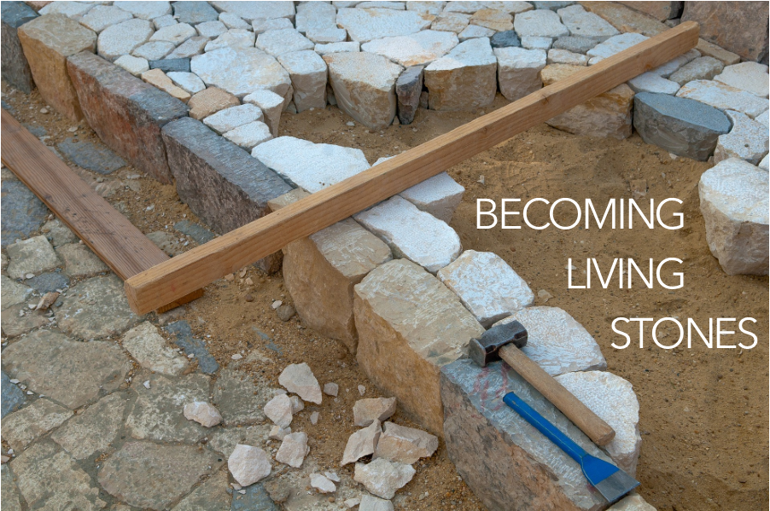

As you come to him, the living Stone - rejected by humans but chosen by God and precious to [God] - you also, like living stones, are being built into a spiritual house to be a holy priesthood, offering spiritual sacrifices acceptable to God through Jesus Christ. For in Scripture it says:

“See, I lay a stone in Zion,

a chosen and precious cornerstone,

and the one who trusts in him

will never be put to shame.”

1 Peter 2:4-6, NIV

Our service of worship begins as we GATHER.

We sing our praises to God,

we are called to worship God,

we confess to God together,

we are reminded of God’s pardon of what we confess, and

we share signs of peace as we greet one another.

When we sing, we sing together, heeding Psalm 84, which encourages us all to:

Make a joyful noise to the Lord, all the earth;

break forth into joyous song and sing praises.

Our worship of God involves us all so there are many times when we speak together or when we respond to the leading of another. These times when we speak (and sing) together are noted by **bold text**.

You are invited to find a stone you can hold, to be included as part of your worship. You will be invited to lay down your stone as a part of our Prayer of Confession.

WELCOME & INVITATION

As you come to him, the living stone - rejected by humans but chosen by God and precious to God…

**We, like living stones, are being built into a spiritual house to be a holy priesthood.**

PRELUDE

CALL TO WORSHIP

Friends, the Risen Lord is among us and walks with us on our journey.

**Open our eyes that we might recognize him and follow him.**

God may come to us, unrecognized, as a stranger as we travel our own Emmaus roads.

**May the words of the Risen Christ burn in our hearts as we continue on our journey.**

Open your eyes this day to see the goodness of the Lord.

**Open our hearts, gracious God, to receive your blessings.**

**IN CHRIST THERE IS NO EAST OR WEST** / Glory to God 317

CALL TO CONFESSION

PRAYER OF CONFESSIONFotW

**Good and gracious God, we are creatures of dust, ignorant of your revelation, misunderstanding of your life, death, and resurrection among us, needing forgiveness. We repent of our failure to give as you have given to us. We beg your mercy for our fallen world. We seek your Word, that we may live with the faith of Jesus. Be our solace in this life and always. We ask this as your own children, holy and incomplete. Forgive us and lead us. Amen.**

ASSURANCE OF FORGIVENESS

Friends, hear the good news! Who is in a position to condemn? Only Christ, and Christ died for us, Christ rose for us, Christ reigns in power for us, Christ prays for us. Anyone who is in Christ is a new creation. The old life has gone; a new life has begun. Know that we are forgiven and be at peace. **Amen.**

We continue our worship as the Word is PROCLAIMED.

We pray that the Holy Spirit helps us receive the Word spoken,

we hear Scripture(s) in song and word,

we listen to a reflection on the Scripture(s), and

we begin our own reflection during a period of quiet.

We RESPOND to the Word as:

We affirm our faith in song,

we offer our prayers to God, and

we commit through offering to God’s work in the world.

On the first Sunday of each month, we celebrate the Lord’s Supper.

Through the seasons of the church, we also baptize children of God, ordain and install officers, and respond to God’s call upon us through other expressions.

CHILDREN’S MESSAGE

PRAYER FOR ILLUMINATION FotW

SCRIPTURE / Luke 24:13-35

MESSAGE

**DAY OF ARISING** / Glory to God 252

PRAYERS OF THE PEOPLE

LORD’S PRAYER

OFFERING

ANNOUNCEMENTS

As the service of worship of God comes to a close, we acknowledge that God SENDS us out into the world to be bearers of the good news of God.

We sing a song affirming the calls God has placed on our hearts,

we receive a charge reminding us of God’s call, and

we are bid into the work of God with a blessing.

**CHRIST IS RISEN! SHOUT HOSANNA!** / Glory to God 248

CHARGE & BENEDICTION

POSTLUDE

FotW: Feasting on the Word: Liturgies for Year B, Volume 1 - Worship Companion; Third Sunday of Easter